EPAM University Programs

DevOps education program

Module 1 DevOps Introduction

TASK 1.1

1. Install GIT on your workstation.
2. Setup git: change your global configs (add name and email, setup core text editor).

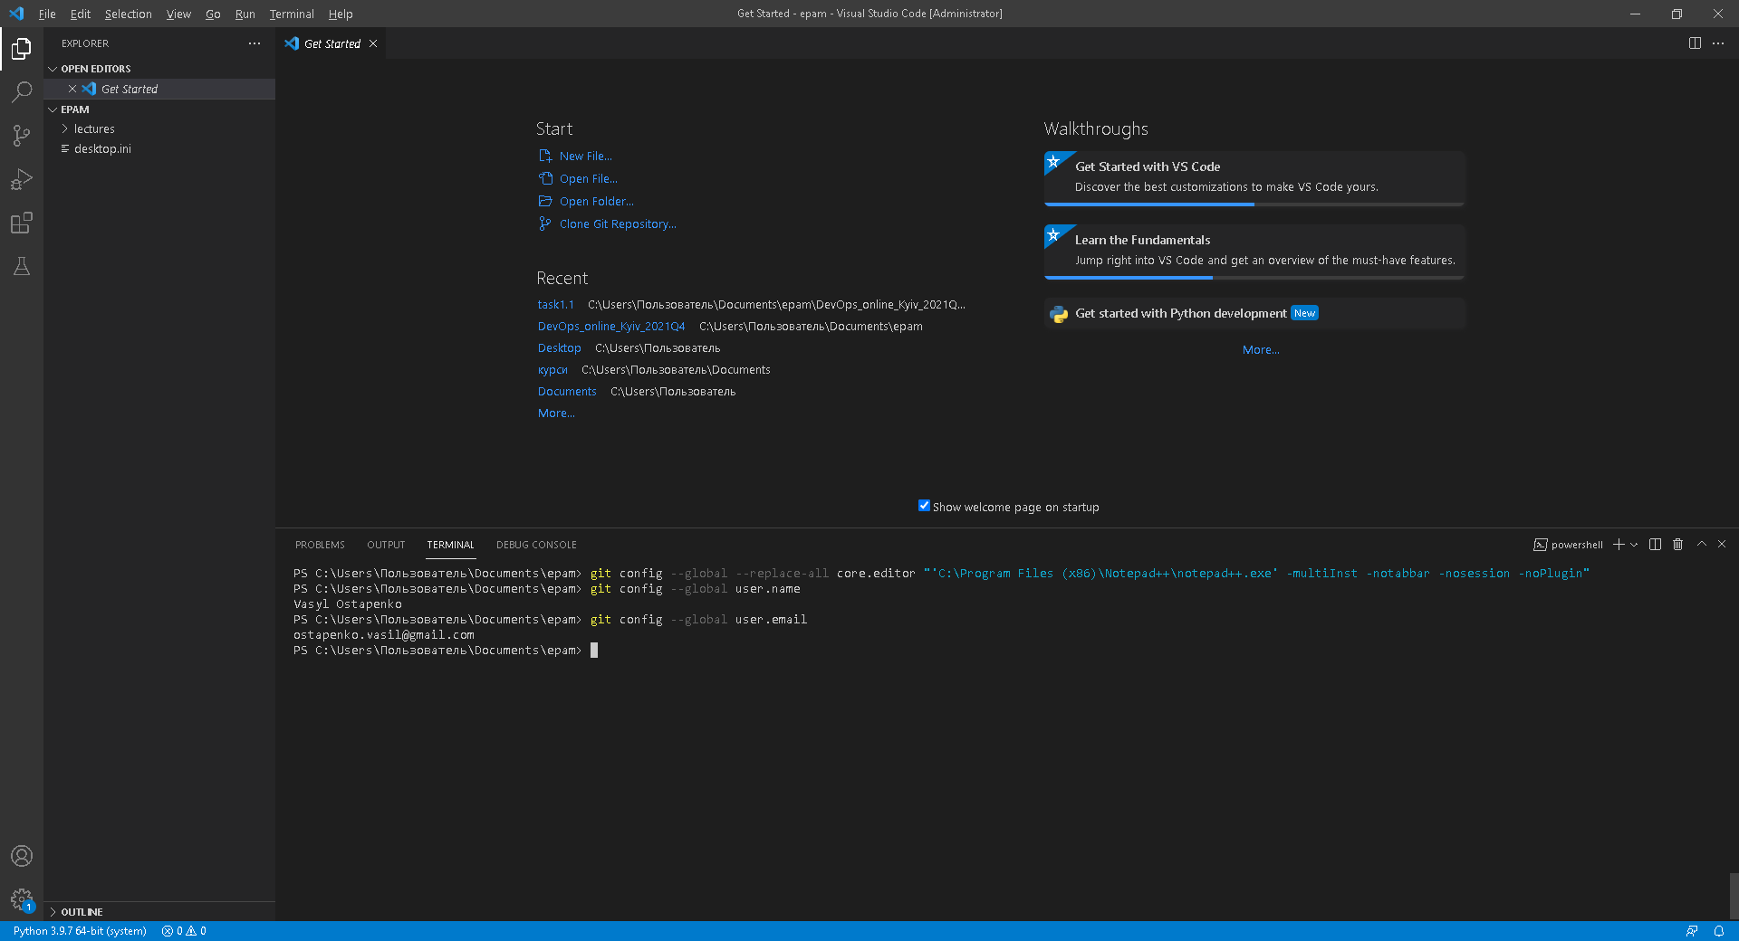

3. Create account on GitHub.

4. Create new private repo on GitHub.

Repo name: DevOps_online_<City>_<year><quarter> Example: DevOps_online_Dnipro_2021Q4

5. You can see example repository structure.

/

m1/

task1.1/

m2/

task2.1/

task2.2/

…

…

m8/

task8.1/

task8.2/

…

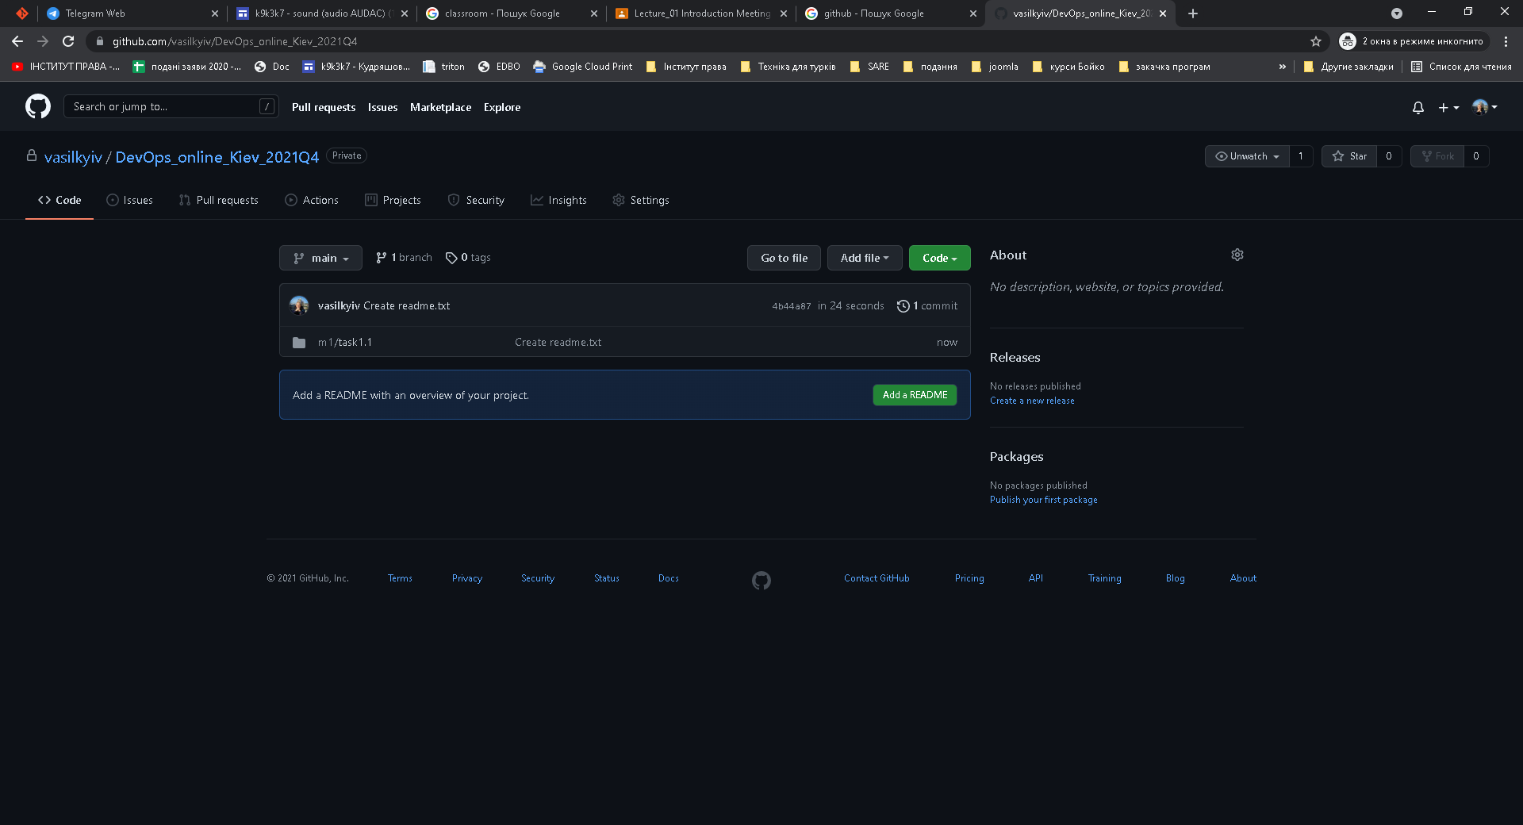

6. Clone repo to your workstation.

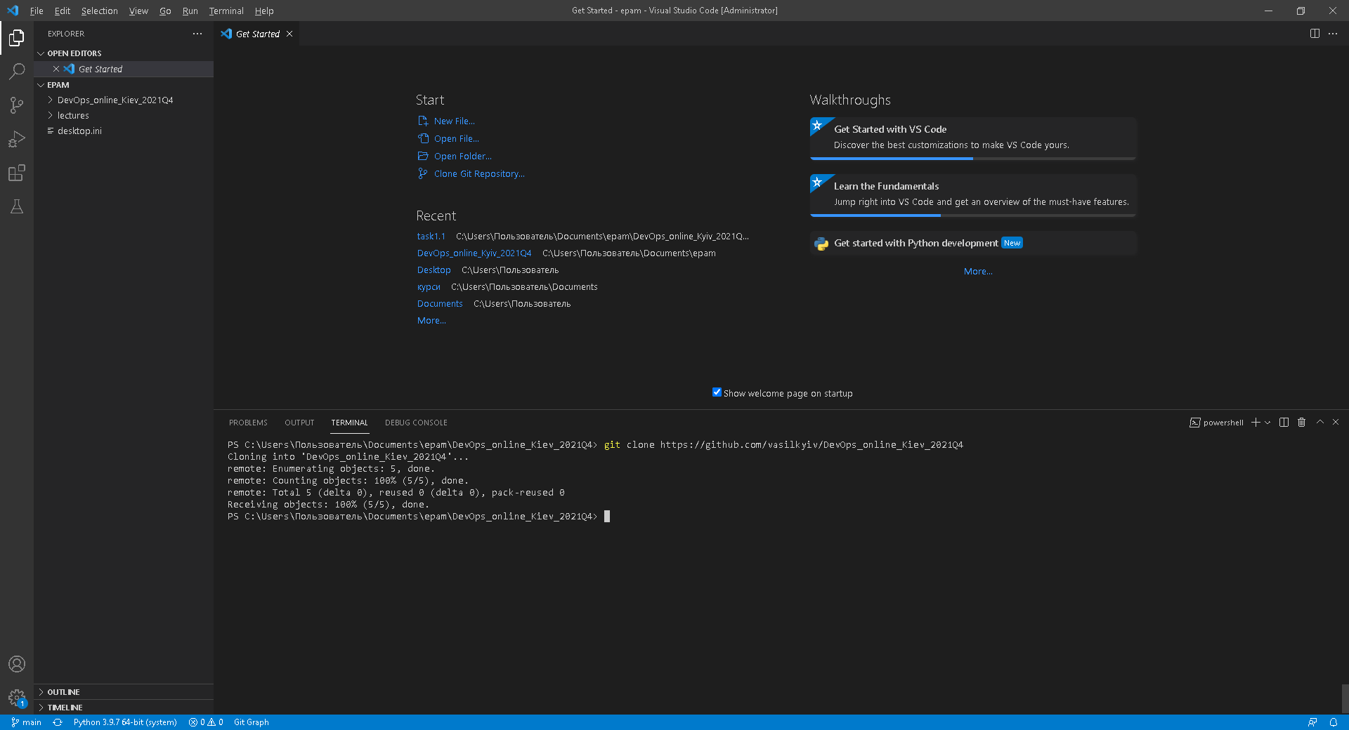

7. Open git console in root directory of your project and make next steps.

8. Do all your experiments in folder “task1.1”.

9. Create empty readme.txt file.

10. Make init commit.

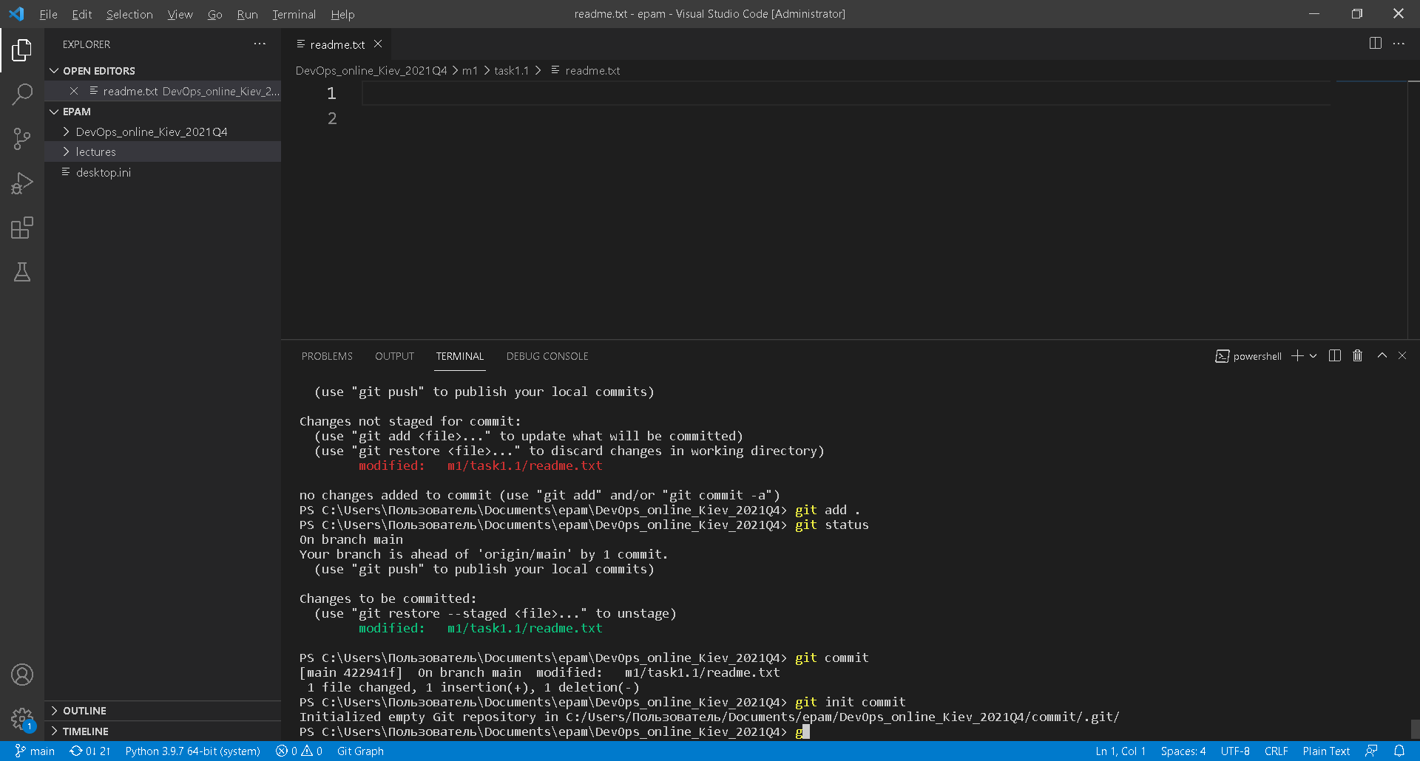

11. Create develop branch and checkout on it.

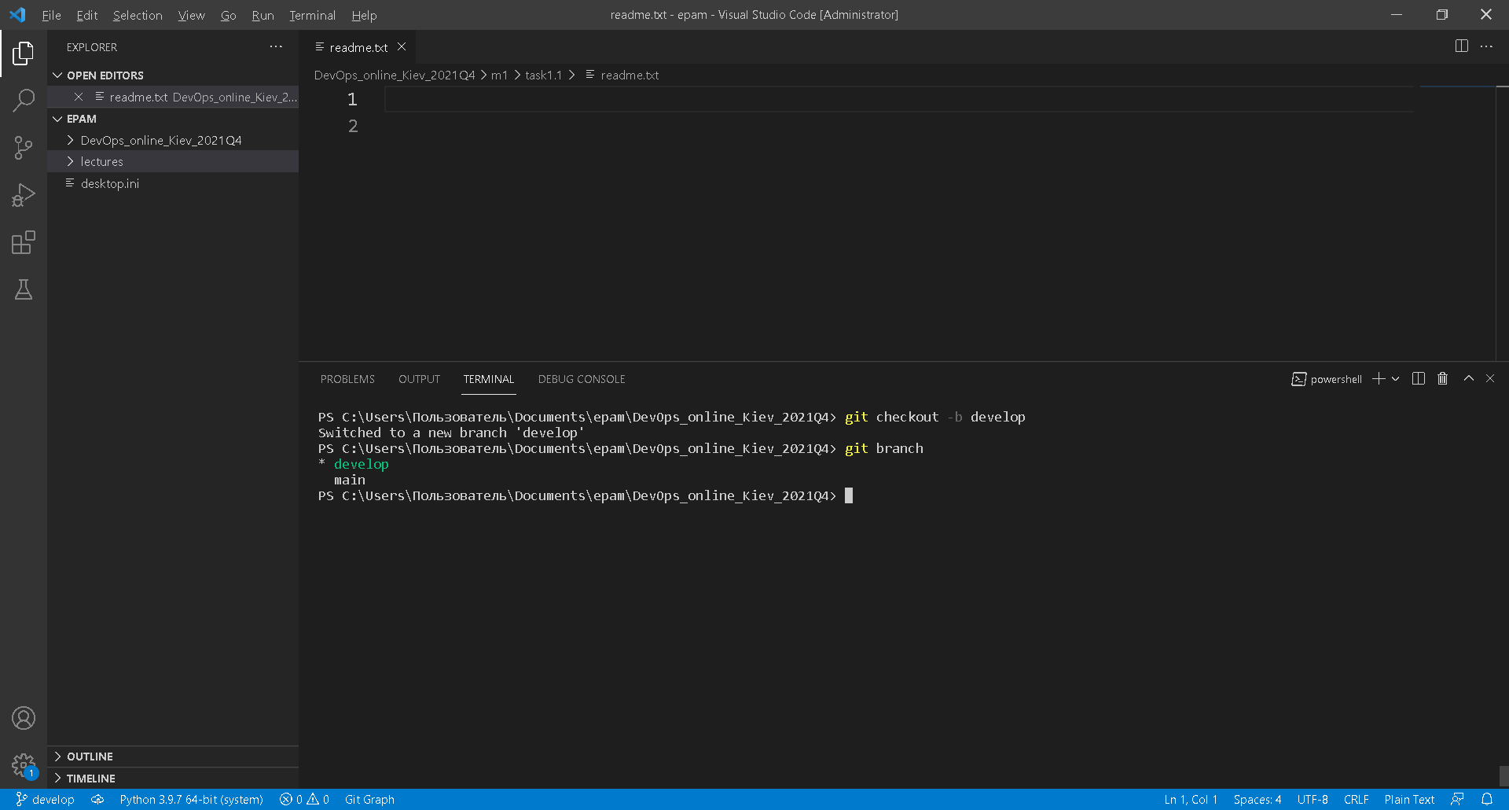

12. Create index.html empty file. Commit.

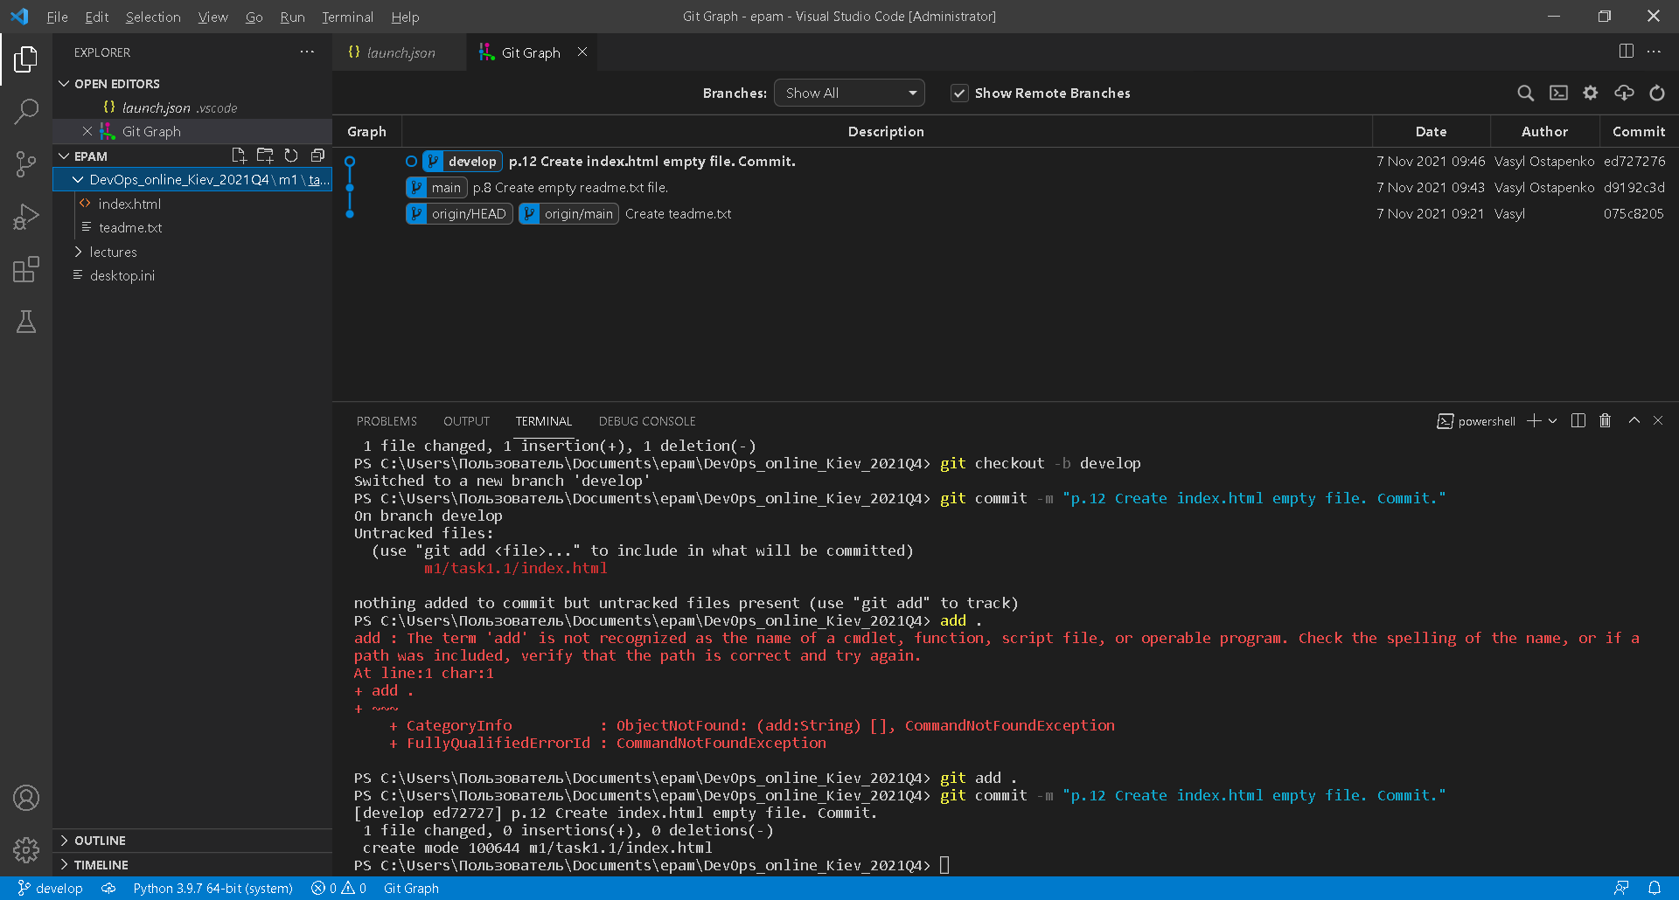

13. Create branch with name “images”. Checkout on it. Add images folder with some images inside it. Commit.

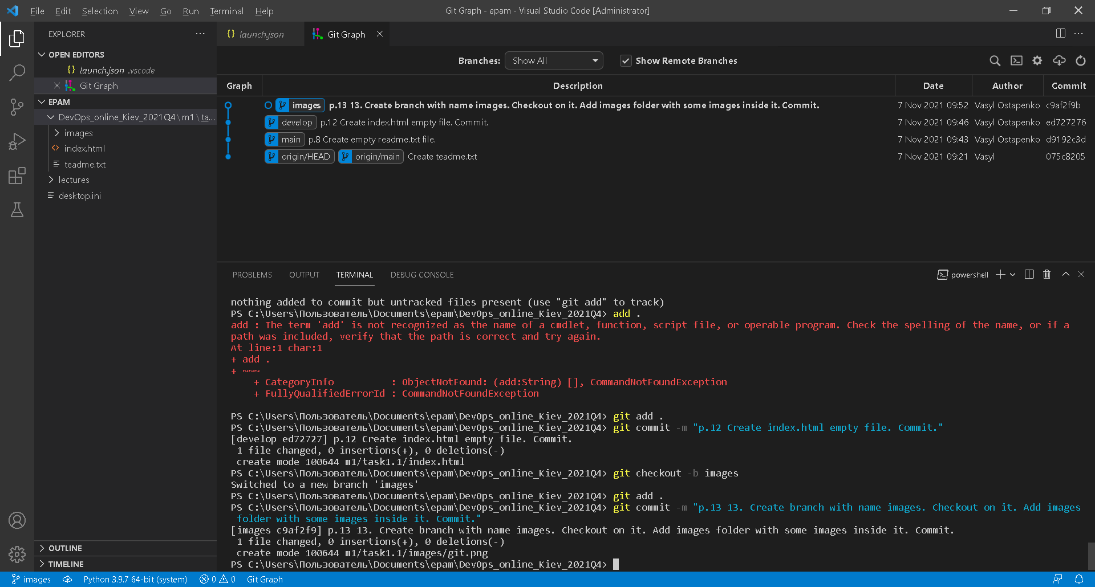

14. Change your index.html. Add images source inside it. Commit.

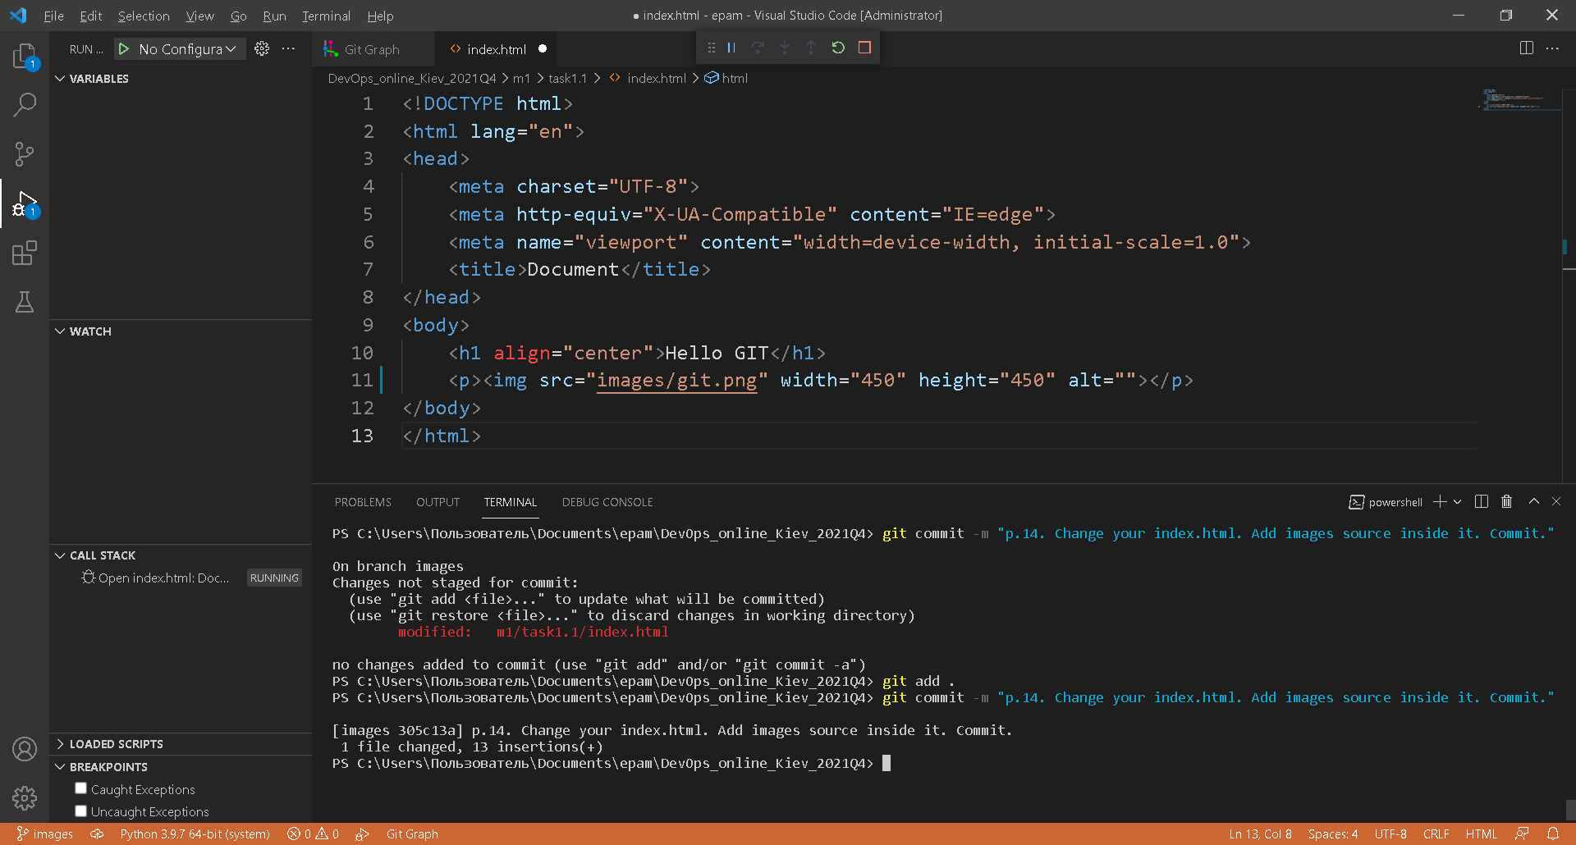

15. Go back to develop branch.

16. Create branch with name “styles”. Checkout on it. Add styles folder with styles source inside it. Commit.

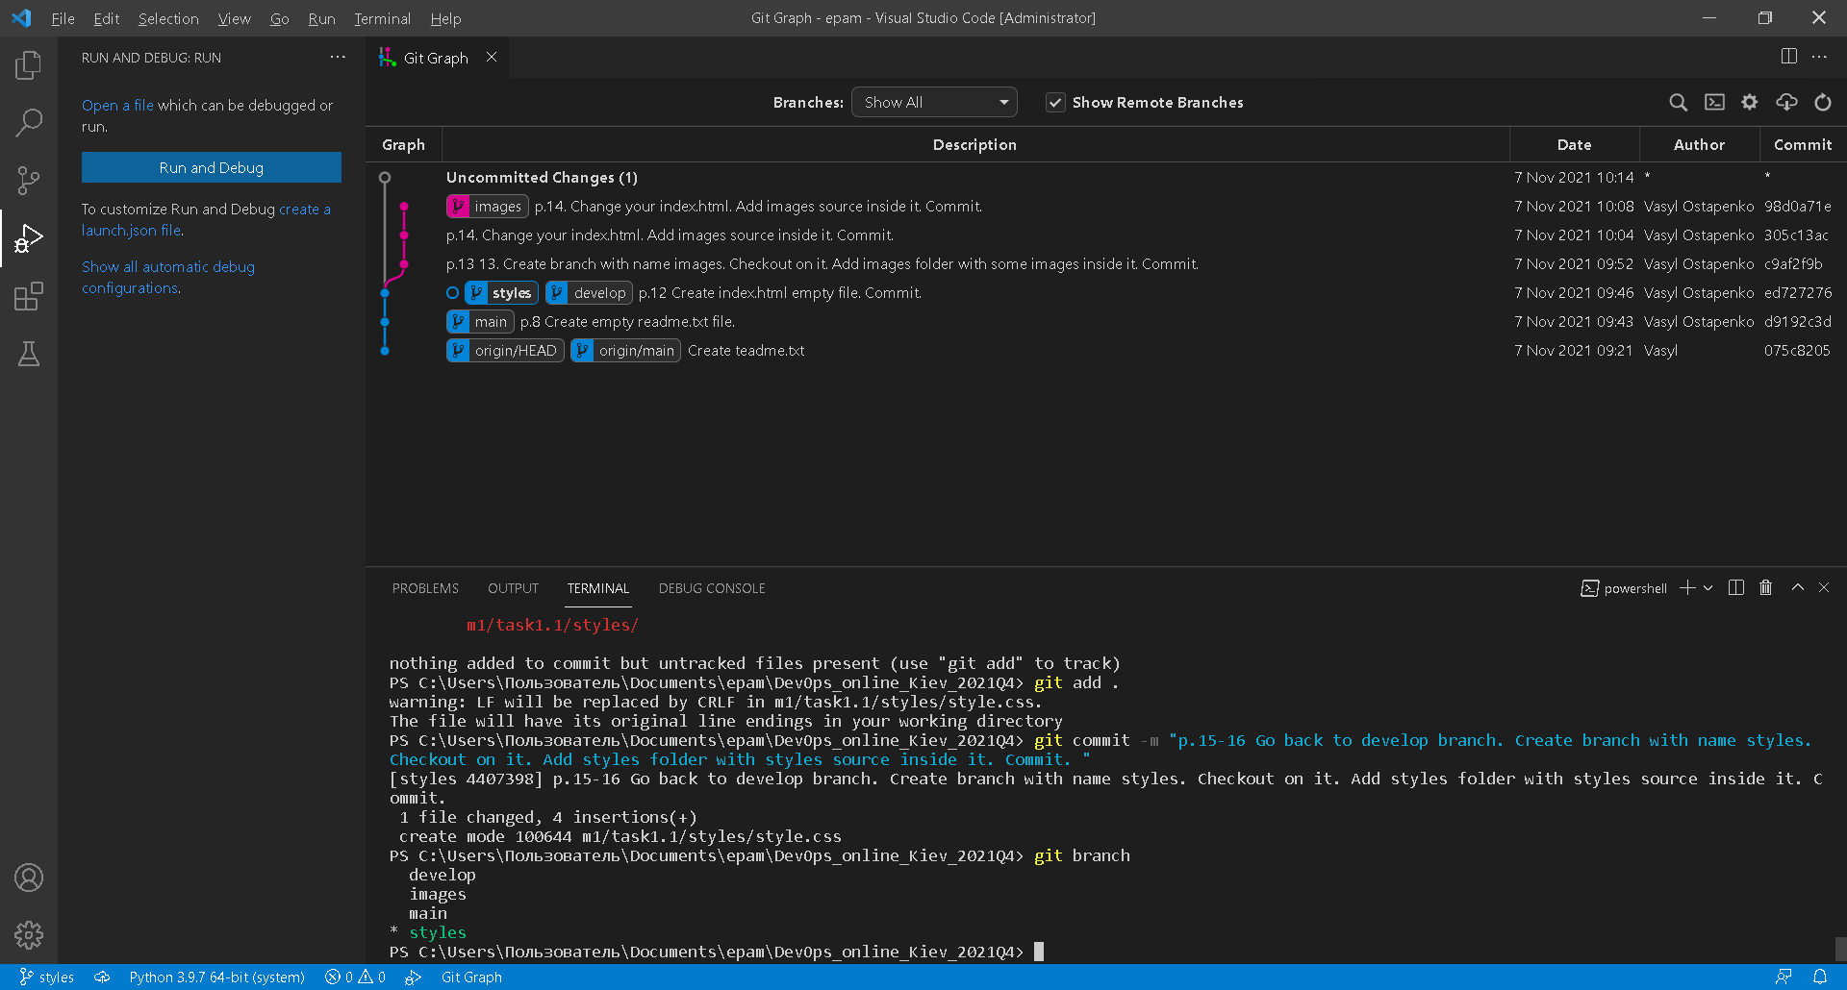

17. Change your index.html. Commit.

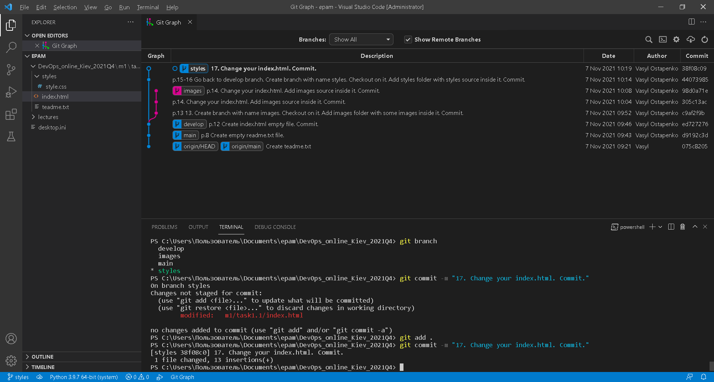

18. Go to develop branch.

19. Merge two new branches into develop using git merge command. Resolve conflict if it appear. Do it in next sequence:

•merge “images” into “develop”

•merge “styles” into “develop”

20. Do not delete any branches!

21. Merge develop into master.

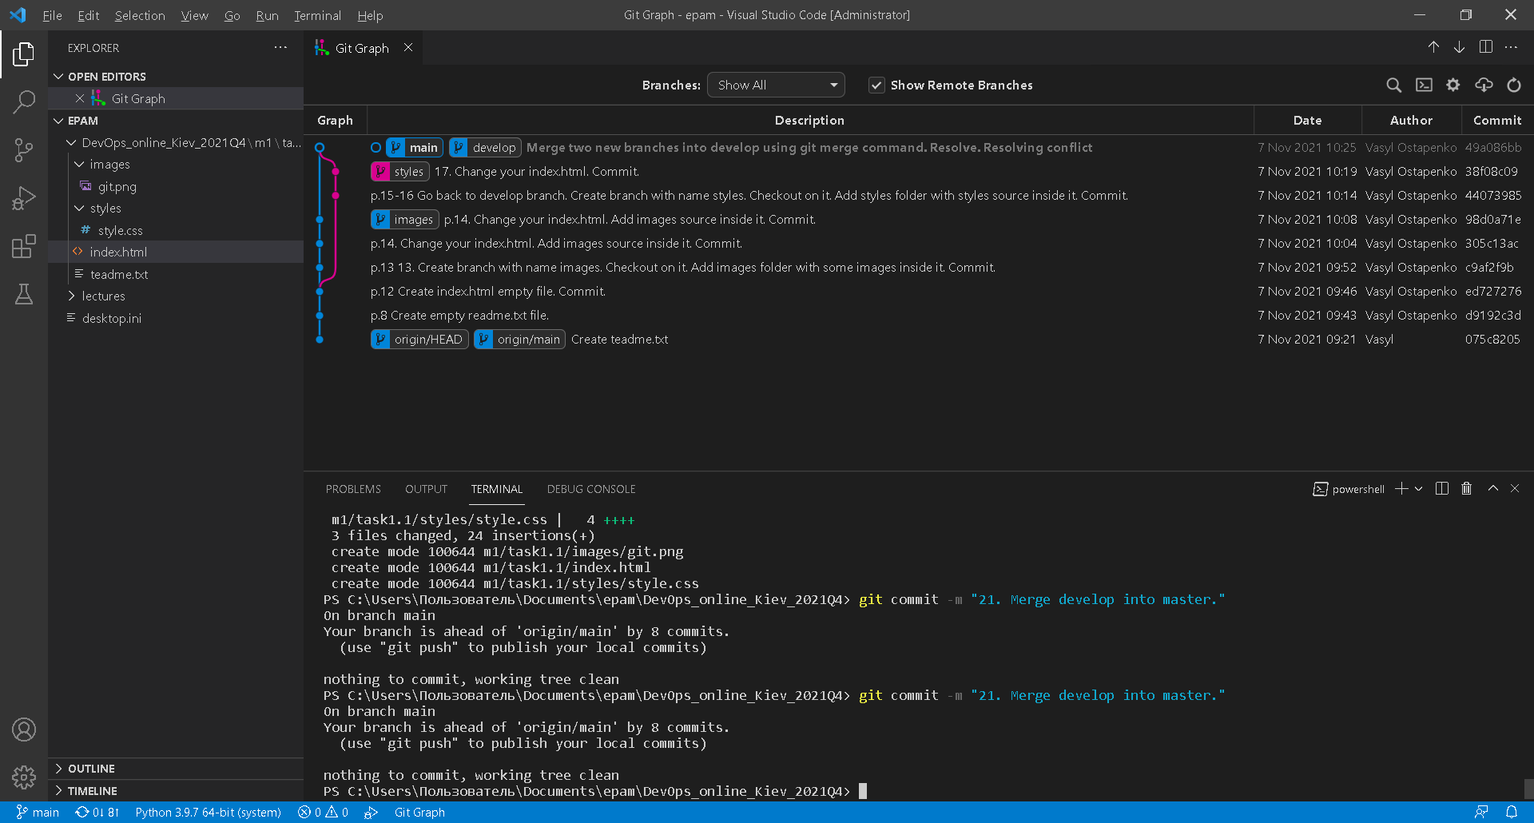

22. Try to inspect your repository with git log command. Use different options with this command (git log --help).

23. Push all your changes with all your branches to origin (git push origin --all).

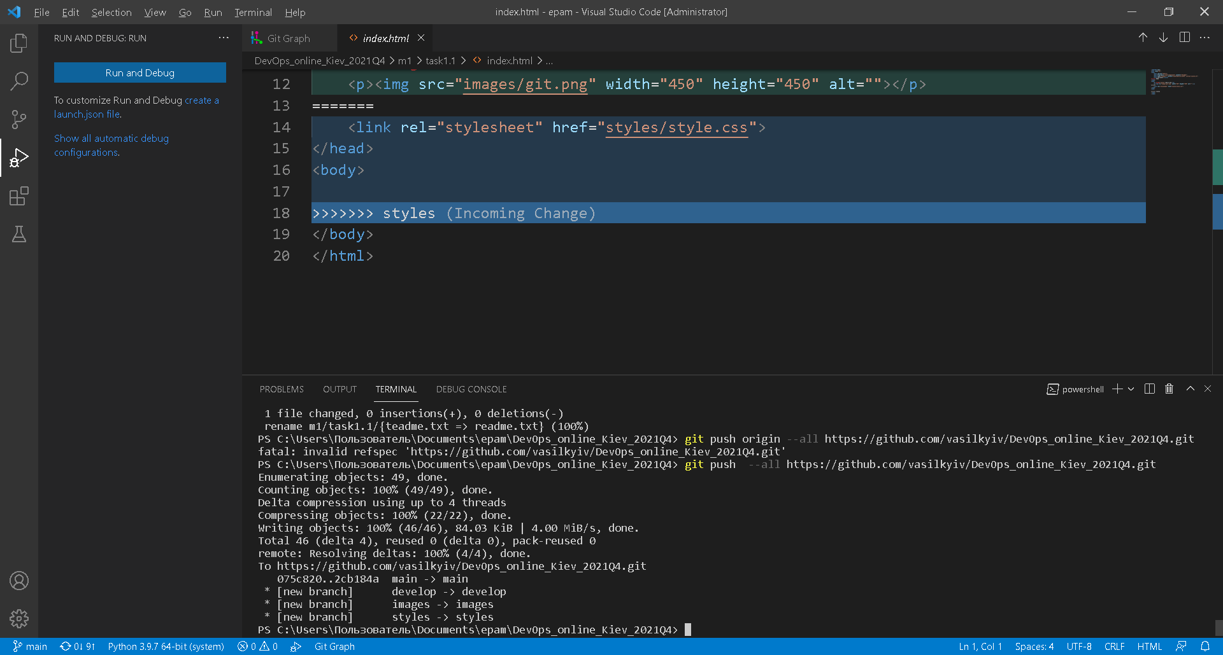

24. Execute command “git reflog“ and save it content somewhere (not in repository) with filename “task1.1_GIT.txt”.

